**Conda Interpreter**

1. Create Conda virtualrtual env

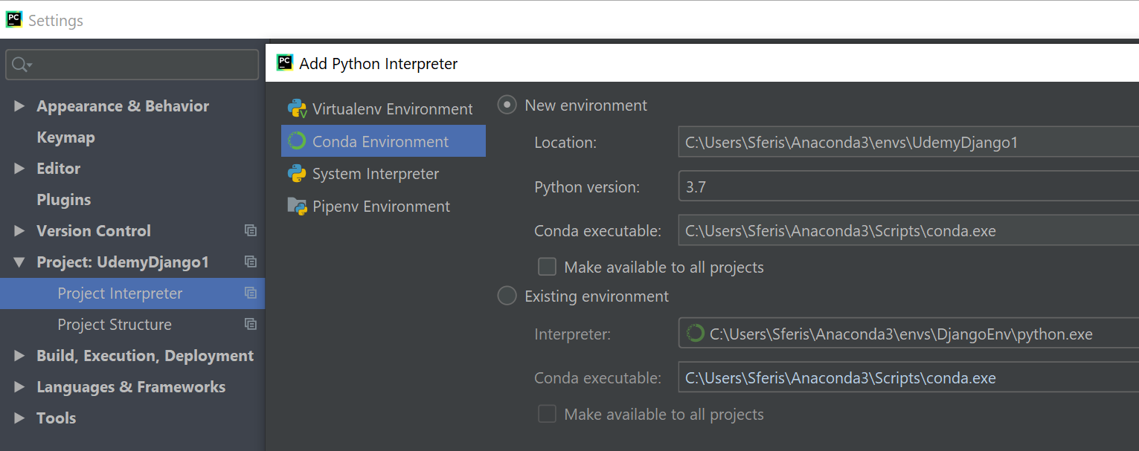

# „Please Specify a different SDK” ---→ Delete env with the same name or all if needed

